**Image Analysis**

**Second Assignment**

**Name: Vishwas Hasija**

**Roll No: 002251121**

**Objective:** The main objective of this program is to enhance a given image using different image enhancing filters by either reducing noise or adjusting contrast. After enhancing image, another objective was to extract contour using edge detectors.

**Steps Taken:**

1. User can enter image file of his choice, if the location or name of file is wrong. It will give user another chance to enter the file name. It will keep on repeating until right file is entered.
2. Once user enter the correct file, he will be given with choice change the contrast of an image. Below are the function which are used to change the contrast of an image:-

* Histogram Equalization: It is used to increase the contrast value of an image when objects in image are represented by closed contrast values.
* Power Law: Power law transform is used to adjust the contrast of any image. Where gamma values >1 will make the image appear brighter and gamma values<1 make the image darker. Option will be given to user to enter value of gamma depending upon image and his/her need.
* Median Filter: It is used to compute the median of all the pixels using kernel window and replace the central pixel with median. It is used to remove the salt and pepper noise.
* 2D filter (Convolution): It is a low pass filter used to blur the image.
* Contrast limited Adaptive Histogram Equalization: An image can be subject to light differently i.e. some part of the image are overexposed to light or some part are underexposed to the light. After performing histogram equalization some details can be lost. To solve this problem, an image is divided in small tiles (for example 8*8) histogram equalisation is performed on this which will result in better output this is called histogram equalization.

1. Once the contrast of any is adjusted it will be input for Median_blur function to reduce the noise. This function will be option for user whether he want to perform median blur or not.
2. After reducing noise and adjusting the contrast, different edge detectors functions can be used like:-

* sobel_x_y : Used to detect edges in x and y direction using Sobel filter and merge them together(gradient).
* Prewitt_x_y: Used to detect edges in x and y direction using Prewit filter and merge them together(gradient).
* Canny edge detector

**Best Solution:**

**For Image MRI**, best option was to first adjust the contrast of image using Contrast Limited Adaptive Histogram equalization (CLAHE). For this image I have selected CLAHE because some part of the image were underexposed and some parts were over exposed as per the property of CLAHE image is bifurcated in small tiles and contrast of these tiles are adjusted separately. Then output of CLAHE is used as input for median blur to reduce the noise outside the skull image. Then median blurred image is taken input for Prewitt filter to detect edges in X (horizontal) and Y (vertical) direction. And combine the X and Y gradient. Output result from Prewitt filter can be improved if median blur function is not applied but then there will be around and inside the skull. While performing contrasting and noise reduction main objective was to reduce the noise around and inside the skull and extract the contours. Please find the below screen shots:

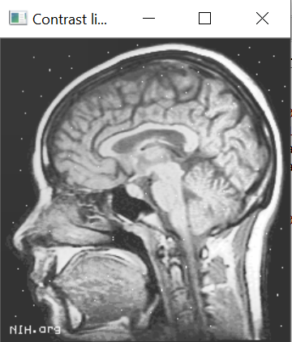 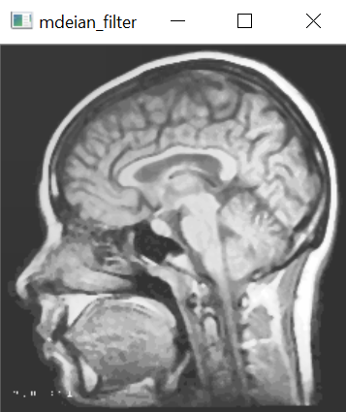

After performing histogram Equalization Median filter has removed salt and pepper

noise

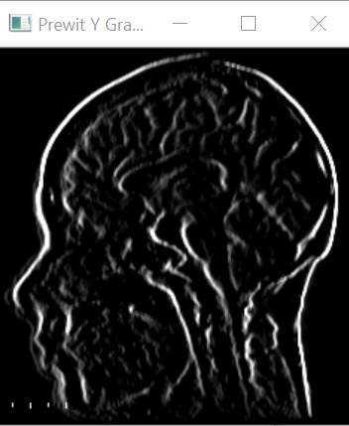 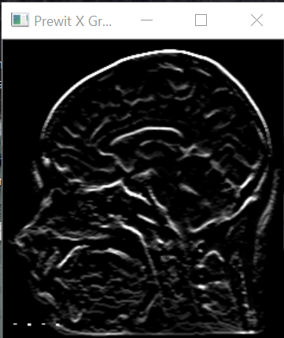

Prewitt filter to find Gradient in Y direction Prewitt filter to find the Gradient in X direction

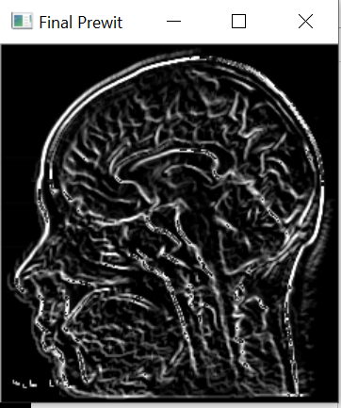

Merged X and Y Gradient

**For Building Image**, optimal steps were to first adjust the contrast of an image using histogram equalization. Here histogram equalization is more effective than Adaptive histogram equalization because of noise in the surrounding. While adaptive histogram equalization consider these noise at part of image. So I chose to perform histogram equalization. Prewitt filters was used to find the gradient in X and Y direction but Canny edge detector is more efficient. No median blur was performed as some of the important information was getting lost Main objective was to get as much as layout of the building.

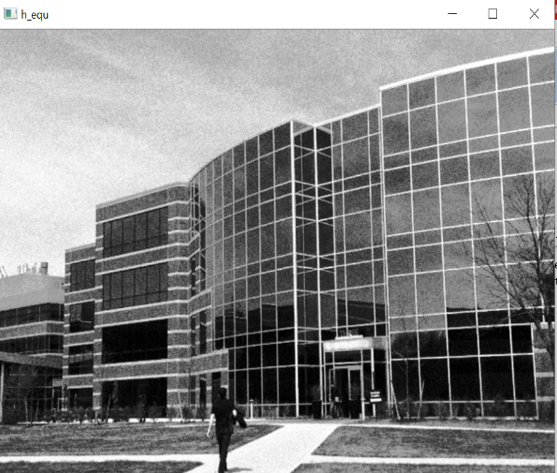 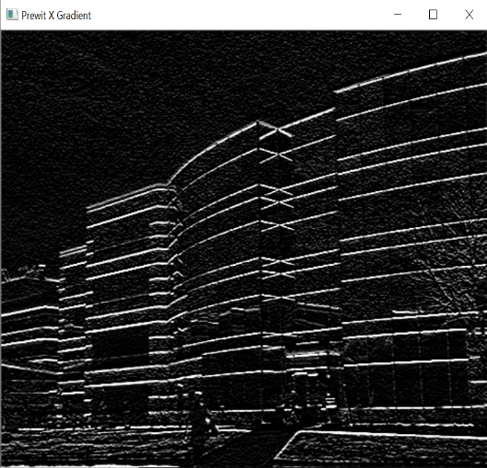

Histogram Equalization Prewitt filter in X direction

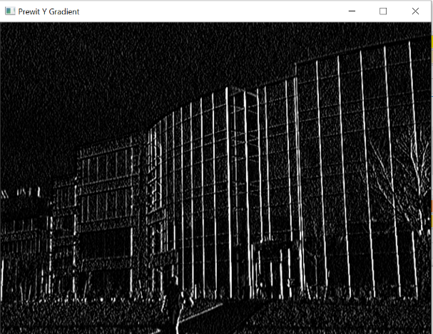 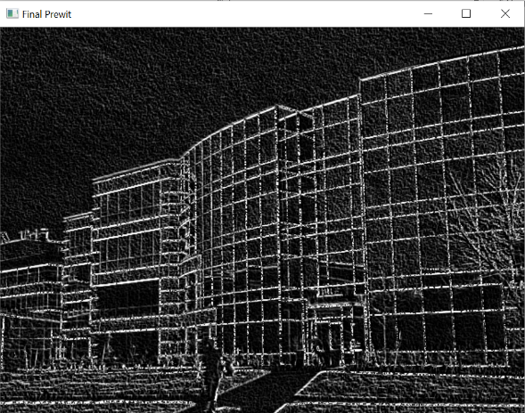

Prewitt filter in Y direction Final Output with Prewitt filter

**For Peppers**, to get optimal results I selected 2D_filter which have 3X3 matrix having all ones. Convolution was performed. It was followed by Sobel filter for edge detection. During this contrast and edge detection main target was to get as many as distinguish peppers as possible.

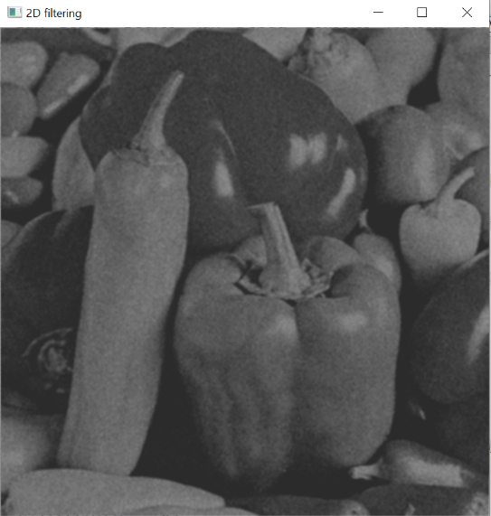 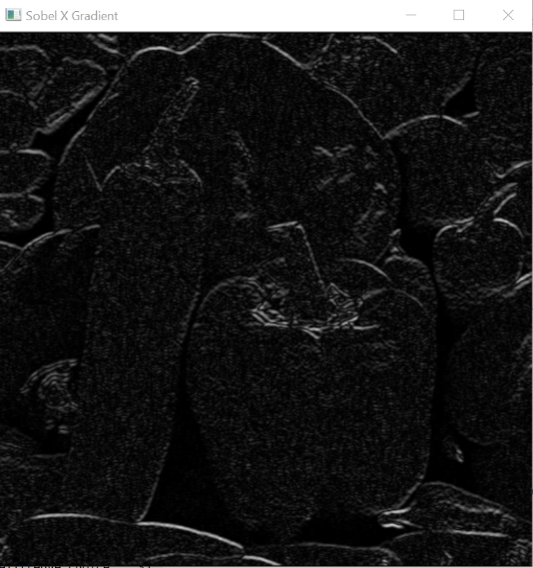

2D filter Sobel filter X direction edge detection 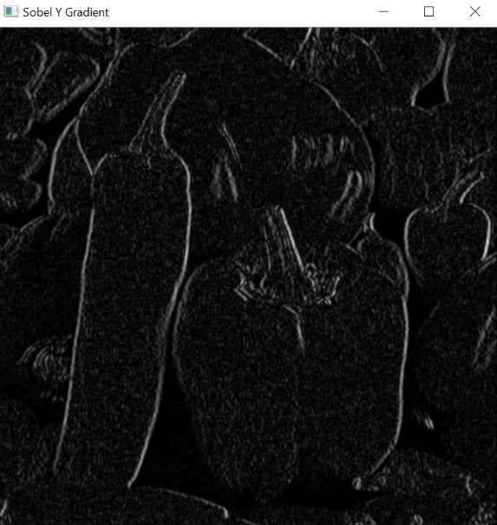 s 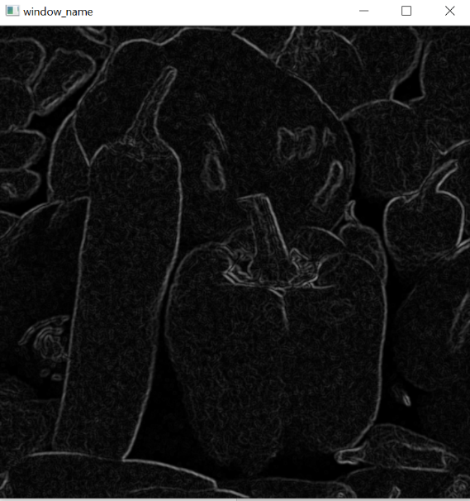

Sobel filter Y direction edge detection Final Prewitt filter Output

Note : Code was written and tested in python 3.7.